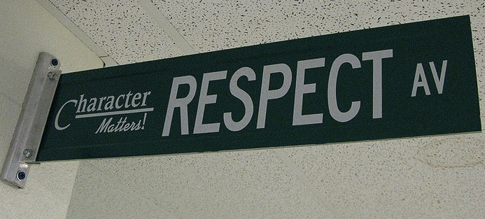
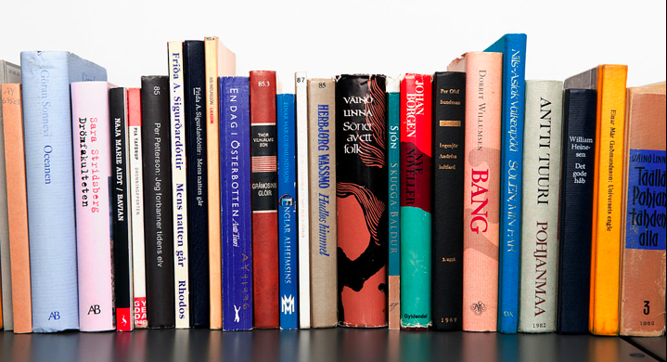
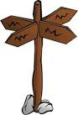
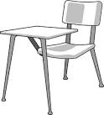
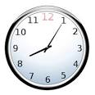

Course Description

Be kind & be respectful.

Class Expectations

Follow directions the first time they are given.

Raise your hand and wait to be called on before speaking.
All school rules also apply.

Ask permission to leave your seat.

Be on time & be prepared.

American Lit

Welcome American Literature. This semester we will be studying a variety of short stories, novels, and plays by authors such as Nathaniel Hawthorne, Edgar Allan Poe, and Harper Lee. We will also focus on vocabulary, grammar, and writing. I look forward to getting to know each of you this semester.
I have certain expectations of you in order for class to run smoothly. I think you will find they are simple.
- Be prepared for class with pencil and paper each day.
- Be in your seat and ready to work when the tardy bell rings.
- Be kind and polite to your classmates and your teacher.
- Turn in all assignments on time.
- Make sure all work is completed to the best of your ability.
- Cell phones are not allowed. They should be stored in your bag or pocket for the duration of class.
- Follow Pickens High School rules for behavior and dress code. You can find these in your Student Handbook.

I have read and understand this syllabus.

(Student signature)
(Parent/guardian signature)
I have read and understand this syllabus.

(Student signature)
(Parent/guardian signature)
I have read and understand this syllabus.
YOU WILL NEED:
- A Gmail account (sign up for one if you don’t have one already)
- A positive attitude, a sense of humor, & an open mind

Grades: Your grade will be broken down into the following categories and percentages:
Formative Assessments = 40%
These assignments include but are not limited to daily writing and work done in class.
Summative Assessments = 60%
These assignments include but are not limited to projects, tests, and essays.
Your final grade will be a combination of your first nine weeks grade = 40%, second nine weeks grade = 40%, and final exam =20%. If you exempt the final your grade is 50/50 average of your first and second nine weeks averages.
This class has a cumulative End of Course Test. We will have daily practice in order to prepare for the test which is cumulative and will take place at the end of the semester.
Plagiarism: Pickens High School Protocol-
Students who have plagiarized any portion of their written work shall receive a grade of 0. For the first offense a student may rewrite the assignment for a grade no higher than 70. Each offense after the first, the student will receive a 0 with no rewrite.

Classroom Policies, Procedures, & Grading

______________________________________
Student Signature

Parent Signature

